[ ] Indicates material parenthetical to the worship planners, to be deleted from the worship folder
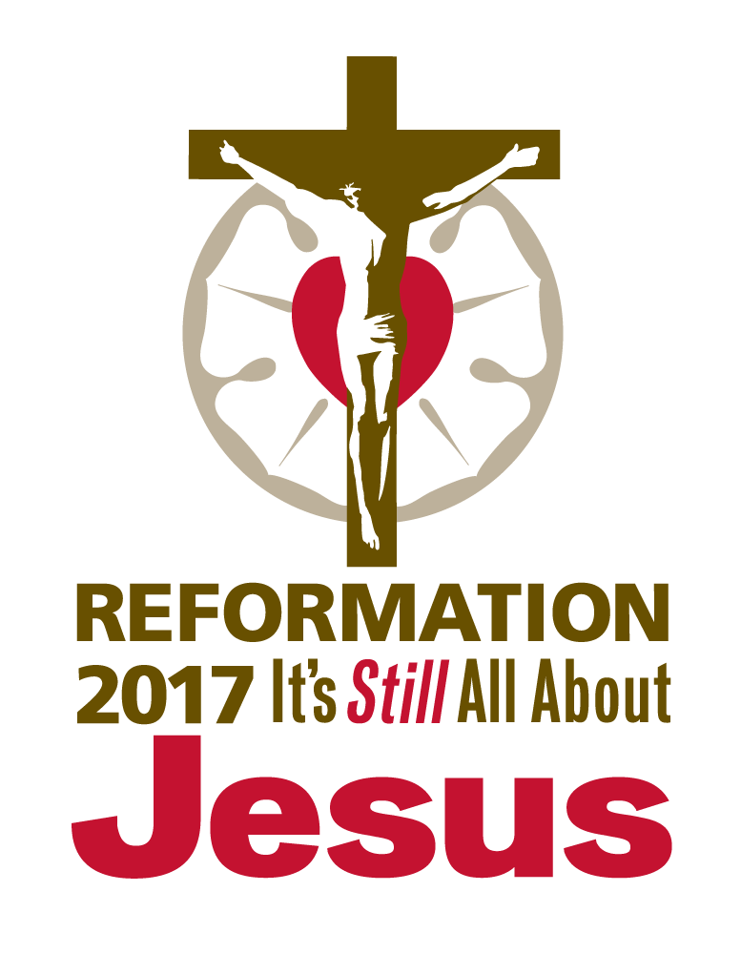
( ) Indicates instructions to the congregation, to appear in the worship folder

PRESENTATION OF THE AUGSBURG CONFESSION

June 25, 2017

AS WE GATHER

While today will slip by for many Lutherans without the fanfare of Reformation Day, June 25 marks the day in 1530 on which God-fearing laymen took their stand for the Gospel and presented their confession of faith before Emperor Charles V at the Diet of Augsburg. You might even call today the birthday of the Lutheran Church! That confession made 487 years ago continues to shape what we believe, teach, and confess before the world today. Centered on Christ and focused on the free gift of salvation that is ours by grace through faith, the Augsburg Confession reminds us of the high privilege it is to confess Jesus Christ. As our lips confess His name and as we worship Him with “psalms and hymns and spiritual songs” (Ephesians 5:19), we rejoice that Jesus confesses us before His Father in heaven!

CONFESSION AND ABSOLUTION

HYMN OF INVOCATION “Preserve Your Word, O Savior” [LSB 658; LW 337; TLH 264]

INVOCATION

The sign of the cross may be made by all in remembrance of their Baptism.

Pastor: In the name of the Father and of the Son and of the Holy Spirit.
People: Amen.

CONFESSION AND ABSOLUTION

Pastor: If we say we have no sin, we deceive ourselves, and the truth is not in us.
People: But if we confess our sins, God, who is faithful and just, will forgive our sins and cleanse us from all unrighteousness.

Silence for reflection on God’s Word and for self-examination.

Pastor: Let us then confess our sins to God our Father.
People: Most merciful God, we confess that we are by nature sinful and unclean. We have sinned against You in thought, word, and deed, by what we have done and by what we have left undone. We have not loved You with our whole heart; we have not loved our neighbors as ourselves. We justly deserve Your present and eternal punishment. For the sake of Your Son, Jesus Christ, have mercy on us. Forgive us, renew us, and lead us, so that we may delight in Your will and walk in Your ways to the glory of Your holy name. Amen.

Pastor: Almighty God in His mercy has given His Son to die for you and for His sake forgives you all your sins. As a called and ordained servant of Christ, and by His authority, I therefore forgive you all your sins in the name of the Father and of the Son and of the Holy Spirit.
People: Amen.

[OR] AC II 1–2; AC XXV 3–5

Pastor: “Since the fall of Adam, all who are naturally born are born with sin, that is, without the fear of God, without trust in God, and with the inclination to sin, called concupiscence,” says Article II of the Augsburg Confession.

People: “Concupiscence is a disease and original vice that is truly sin. It damns and brings eternal death on those who are not born anew through Baptism and the Holy Spirit.”

Pastor: Let us come before our Lord in confession, acknowledging the disease of the Old Adam within us, and receive the healing forgiveness that is ours in the Second Adam, our Lord Jesus Christ.

(In silent prayer, we reflect on our sin and our need for the Savior.)

Pastor: Let us then confess our sins to God our Father.

People: Heavenly Father, we confess that we are sinful from birth and deserving of Your condemnation. We do not fear You as we ought, nor do we trust in You above all things. By what we have done and what we have failed to do, we have broken the commands of Your Word. Through the power of Your Holy Spirit, whom You have given to us in Baptism, cleanse our hearts and renew our spirits. Draw us again to the cross of Christ that we may receive the forgiveness He alone can give. Amen.

Pastor: “Our people are taught that they should highly prize the Absolution as being God’s voice and pronounced by God’s command,” says Article XXV of the Augsburg Confession. “The Power of the Keys is set forth in its beauty. [We] are reminded what great consolation it brings to anxious consciences.”

People: We are also reminded, “God requires faith to believe such Absolution as a voice sounding from heaven. . . . Such faith in Christ truly obtains and receives the forgiveness of sins.”

Pastor: Almighty God in His mercy has given His Son to die for you and for His sake forgives you all your sins. As a called and ordained servant of Christ, and by His authority, I therefore forgive you all your sins in the name of the Father and of the Son and of the Holy Spirit.
People: Amen.

SERVICE OF THE WORD

ENTRANCE HYMN “Brave Hearts Made Bold, God’s Truth Confessed” [See service
downloads for
music.]

Brave hearts made bold, God’s truth confessed,
Both life and honor daring;
The apostolic faith expressed,
Before the world declaring
That God is one, yet One in Three,
Coequal in their majesty:
God—Father, Son, and Spirit.
God’s only Son embraced our shame,
Our tent of flesh assuming;
This guiltless Lord our sin became,
Sin’s wage to death Him dooming:
In Pontius Pilate’s judgment hall,
Bedecked in bloodied, purple pall,
Christ made the good confession.
Our full forgiveness Christ has won;
What sinless, selfless dying!
Faith trusts all Jesus Christ has done—
His merit, justifying!
His holy, spotless righteousness,
We here believe and here confess;
No work can gain God’s favor.
O Lord, I love Your holy house,
Your glory here is dwelling:
Your Law is preached my heart to rouse,
To censure its rebelling;
Your Gospel words of truth and grace,
All fears within my heart erase—
Glad news of peace, O Jesus!
Your steadfast love before my eyes;
Your faithfulness, my blessing!
Your truth I cannot compromise,
Before the world confessing;
For in Your Word and Sacrament,
I find my strength and am content
And taste the joy of heaven.
In You, Lord Christ, I have no fear,
Nor fear the world’s defaming;
Your hidden, whispered word is clear—
My joy, its clear proclaiming!
Though hostile foes my body kill,
My soul is safe within Your will,
Avowed before Your Father.
Brave hearts, be bold! God’s truth confess,
Your life and honor daring;
The apostolic faith express,
By word and deed declaring
The love of God in Christ for all,
That all may heed Love’s wedding call
And feast with God forever!

KYRIE (p. ___ in hymnal)

HYMN OF PRAISE (p. ___ in hymnal)

SALUTATION

Pastor: The Lord be with you.
People: And also with you.

COLLECT OF THE DAY

Pastor: Let us pray.
Lord God, heavenly Father, You preserved the teaching of the apostolic Church through the confession of the true faith at Augsburg. Continue to cast the bright beams of Your light upon Your Church that we, being instructed by the doctrine of the blessed apostles, may walk in the light of Your truth and finally attain to the light of everlasting life; through Jesus Christ, our Lord, who lives and reigns with You and the Holy Spirit, one God, now and forever.
People: Amen.

[OR]

Pastor: Let us pray.
Lord God, eternal King, You have built Your Church on the foundation of the apostles and prophets with Jesus Christ as the chief cornerstone. As You preserved the proclamation of Your Word through the confession at Augsburg in 1530, keep us firm in the true faith this day also. Send forth Your Holy Spirit that we may confess Your Son before others, knowing that He confesses us before Your throne of grace; through Jesus Christ, Your Son, our Lord, who lives and reigns with You and the Holy Spirit, one God, now and forever.
People: Amen.

OLD TESTAMENT READING Nehemiah 8:1–12 (Ezra reads the Book of the Law.)

Lector: This is the Word of the Lord.
People: Thanks be to God.

PSALM Psalm 26 [See service downloads for festival setting.]

EPISTLE 1 Timothy 6:11b–16 (“Fight the good fight of the faith.”)

Lector: This is the Word of the Lord.
People: Thanks be to God.

ALLELUIA and VERSE Psalm 119:46 [See service downloads for festival setting.]

Alleluia. I will also speak of Your testimonies before kings and shall not be put to shame. Alleluia.

HOLY GOSPEL Matthew 10:26–33 (Do not fear those who persecute.)

Pastor: The Holy Gospel according to St. Matthew, the tenth chapter.
People: Glory to You, O Lord.

(The Gospel is read.)

Pastor: This is the Gospel of the Lord.
People: Praise to You, O Christ.

CHILDREN’S MESSAGE [See service downloads for message resources.]

HYMN OF THE DAY “Salvation unto Us Has Come” [LSB 555; LW 355; TLH 377;
see service downloads for festival settings.]

SERMON “Confess Jesus—It’s Good for Your Soul” [See service downloads for
sermon resources.]

CREED Nicene Creed (as found in the hymnal)

[OR]

All: I believe in one God,
the Father Almighty,
maker of heaven and earth
and of all things visible and invisible.

And in one Lord Jesus Christ,
the only-begotten Son of God,
begotten of His Father before all worlds,
God of God, Light of Light,
very God of very God,
begotten, not made,
being of one substance with the Father,
by whom all things were made;
who for us men and for our salvation came down from heaven
and was incarnate by the Holy Spirit of the virgin Mary
and was made man;
and was crucified also for us under Pontius Pilate.
He suffered and was buried.
And the third day He rose again according to the Scriptures
and ascended into heaven
and sits at the right hand of the Father.
And He will come again with glory to judge both the living and the dead,
whose kingdom will have no end.

And I believe in the Holy Spirit,
the Lord and giver of life,
who proceeds from the Father and the Son,
who with the Father and the Son together is worshiped and glorified,
who spoke by the prophets.
And I believe in one holy Christian and apostolic Church,
I acknowledge one Baptism for the remission of sins,
and I look for the resurrection of the dead
and the life of the world to come. Amen.

PRAYER OF THE CHURCH

Pastor: Let us pray for the whole people of God in Christ Jesus and for all people according to their needs.
For the land in which we live and work, that all people may acknowledge the merciful goodness of the Creator, let us pray to the Lord.
People: We confess You as our merciful Lord!

Pastor: For the Church and her faithful confession throughout the world, that rejoicing in our heritage, we may boldly share the saving Gospel of grace, let us pray to the Lord.
People: We confess You as our saving Lord!

Pastor: For all who lead others in our homes and workplaces, that our vocations may be opportunities to live out our confession in action and in truth, let us pray to the Lord.
People: We confess You as our living Lord!

Pastor: For [name of congregation], that our common confession of Christ and sharing in the Means of Grace may bring blessings to many lives, let us pray to the Lord.
People: We confess You as our gracious Lord!

Pastor: For all who come to the Lord for healing, [especially . . .], that they may experience the peace of Jesus and give Him thanks in all circumstances, let us pray to the Lord.
People: We confess You as our healing Lord!

Pastor: For these and all other needs we have, trusting that as we confess Jesus Christ before others, He is confessing us before the Father in heaven, let us pray to the Lord.
People: We confess You as our faithful Lord! Amen.

OFFERING

OFFERTORY (p. ___ in hymnal)

SERVICE OF THE SACRAMENT

PREFACE

Pastor: The Lord be with you. 2 Timothy 4:22
People: And also with you.

Pastor: Lift up your hearts. [Colossians 3:1]
People: We lift them to the Lord.

Pastor: Let us give thanks to the Lord our God. [Psalm 136]
People: It is right to give Him thanks and praise.

PROPER PREFACE

Pastor: It is truly good, right, and salutary that we should at all times and in all places give thanks to You, holy Lord, almighty Father, everlasting God, through Jesus Christ, our Lord, who on this day overcame death and the grave and by His glorious resurrection opened to us the way of everlasting life. Therefore with angels and archangels and with all the company of heaven we laud and magnify Your glorious name, evermore praising You and saying:

[OR]

Pastor: It is truly good, right, and salutary that we should at all times and in all places give thanks to You, O Lord, holy Father, almighty and everlasting God, for Your life-giving, life-sustaining Word. Preserved by Your mighty hand through the ages, this Word is our lasting heritage and our source of life each day. By Your Word, You draw us to the cross of Your Son, Jesus Christ, who died our death that we might live in and through Him for all eternity. Therefore with angels and archangels and with all the company of heaven we laud and magnify Your glorious name, evermore praising You and saying:

SANCTUS (p. ___ in hymnal)

PRAYER OF THANKSGIVING

Pastor: Blessed are You, Lord of heaven and earth, for You have had mercy on those whom You created and sent Your only-begotten Son into our flesh to bear our sin and be our Savior. With repentant joy we receive the salvation accomplished for us by the all-availing sacrifice of His body and His blood on the cross.
Gathered in the name and the remembrance of Jesus, we beg You, O Lord, to forgive, renew, and strengthen us with Your Word and Spirit. Grant us faithfully to eat His body and drink His blood as He bids us do in His own testament. Gather us together, we pray, from the ends of the earth to celebrate with all the faithful the marriage feast of the Lamb in His kingdom, which has no end. Graciously receive our prayers; deliver and preserve us. To You alone, O Father, be all glory, honor, and worship, with the Son and the Holy Spirit, one God, now and forever.
People: Amen.

[OR]

Pastor: Blessed are You, O Lord our God, King of all creation, for You have had mercy on us and given Your only-begotten Son, Jesus Christ, that whoever confesses Him as Lord shall live with Him for all eternity. Gathered in the name and remembrance of Jesus, we ask You, O Lord, to cleanse our hearts and renew our minds by Your Holy Spirit. You alone are the fountain and source of all goodness, and we give You thanks and praise for the goodness we receive in the body and blood of Your Son, our Savior, Jesus Christ.
People: Amen.

THE WORDS OF OUR LORD Matthew 26:26–28; Mark 14:22–24; Luke 22:19–20; 1 Corinthians 11:23–25

Pastor: Our Lord Jesus Christ, on the night when He was betrayed, took bread, and when He had given thanks, He broke it and gave it to the disciples and said: “Take, eat; this is My body, which is given for you. This do in remembrance of Me.”
In the same way also He took the cup after supper, and when He had given thanks, He gave it to them, saying: “Drink of it, all of you; this cup is the new testament in My blood, which is shed for you for the forgiveness of sins. This do, as often as you drink it, in remembrance of Me.”

PROCLAMATION OF CHRIST

Pastor: As often as we eat this bread and drink this cup, we proclaim the Lord’s death until He comes. 1 Corinthians 11:26
People: Amen. Come, Lord Jesus. Revelation 22:20

Pastor: O Lord Jesus Christ, only Son of the Father, in giving us Your body and blood to eat and to drink, You lead us to remember and confess Your holy cross and passion, Your blessed death, Your rest in the tomb, Your resurrection from the dead, Your ascension into heaven, and Your coming for the final judgment. So remember us in Your kingdom and teach us to pray:

LORD’S PRAYER (Matthew 6:9–13)

People: Our Father who art in heaven,
hallowed be Thy name,
Thy kingdom come,
Thy will be done on earth
as it is in heaven;
give us this day our daily bread;
and forgive us our trespasses
as we forgive those
who trespass against us;
and lead us not into temptation,
but deliver us from evil.
For Thine is the kingdom
and the power and the glory
forever and ever. Amen.

PAX DOMINI

Pastor: The peace of the Lord be with you always.
People: Amen.

AGNUS DEI (p. ___ in hymnal)

DISTRIBUTION HYMNS

“Draw Near and Take the Body of the Lord” [LSB 637; LW 240; TLH 307]
“I Come, O Savior, to Thy Table” [LSB 618; LW 242; TLH 315]
“Just as I Am, without One Plea” [LSB 570; LW 359; TLH 388]

POST-COMMUNION CANTICLE (p. ___ in hymnal)

POST-COMMUNION COLLECT

Pastor: We give thanks to You, almighty God, that You have refreshed us through this salutary gift, and we implore You that of Your mercy You would strengthen us through the same in faith toward You and in fervent love toward one another; through Jesus Christ, Your Son, our Lord, who lives and reigns with You and the Holy Spirit, one God, now and forever.
People: Amen.

[OR]

Pastor: We give thanks to You, almighty God, that You have refreshed us through Your Means of Grace. By Your Word, Jesus Christ has spoken to us. May He now speak through us as we confess Him before the world. By Your Supper, Jesus Christ has served us. May He now serve others through us as we share the forgiveness He has given by His death and resurrection. For to You, O Father, be all glory and praise, with the Son and the Holy Spirit, one God, now and forever.
People: Amen.

BENEDICTION

Pastor: The Lord bless you and keep you.
The Lord make His face shine on you and be gracious to you.
The Lord look upon you with favor and give you peace. Numbers 6:24–26
People: Amen.

HYMN “Lord of Our Life” [LSB 659; LW 301; TLH 258]
ACKNOWLEDGMENTS
Published by Concordia Publishing House
3558 S. Jefferson Ave., St. Louis, MO 63118-3968
1-800-325-3040 • www.cph.org
Copyright © 2016 The Lutheran Church—Missouri Synod
Other than downloading this resource for personal, Bible study, classroom, or congregational use, other usage is prohibited. No part of this material may be transmitted in any form or by any means, electronic, mechanical, recording, or otherwise, without prior written permission of Concordia Publishing House.
Scripture quotations are from the ESV® Bible (The Holy Bible, English Standard Version®), copyright © 2001 by Crossway, a publishing ministry of Good News Publishers. Used by permission. All rights reserved.
“Brave Hearts Made Bold, God’s Truth Confessed” copyright © 2016 Stephen P. Starke, admin. Concordia Publishing House. All rights reserved. Used by permission.
Some liturgical material taken from Lutheran Service Book, Divine Service: Setting One, copyright © 2006 Concordia Publishing House. All rights reserved. Used by permission.
The quotations from the Augsburg Confession in this publication are from Concordia: The Lutheran Confessions, second edition; edited by Paul McCain et al., copyright © 2006 Concordia Publishing House. All rights reserved.
Service author Jeff Alexander
“Brave Hearts Made Bold, God’s Truth Confessed” (text) Stephen P. Starke
“Brave Hearts Made Bold, God’s Truth Confessed” (music) Kevin Hildebrand
Psalm, Verse, and Hymn of the Day settings James Marriott

